**ECE 2323: Electrical Engineering Science II**

# Laboratory No. 4: Boost Converter

The goal of this laboratory is to introduce you to power supply design. Power supply design is a very important part of both analog and digital electronics. Though we haven’t formally studied this topic yet, we have learned about many of the basic elements that go into power supply design. In this laboratory, we will introduce you to the basic concepts, and then provide you an opportunity to build a more complex circuit using transformers.

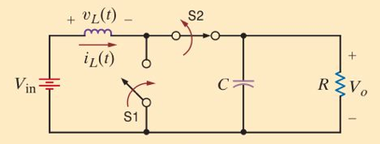

Figure 1. A demonstration of the basic principle behind a boost converter.

In many applications, particularly electrical systems involving DC batteries, you have a need to generate a DC voltage much higher than the source voltage. For example, you might need a 12V supply, but you only have a 4.5V power supply (e.g., 3 AA batteries).

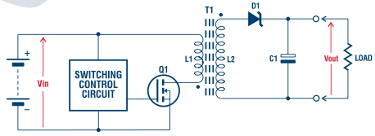

Figure 2. A more complex DC to DC converter using a transformer and a switching control circuit.

In Figure 1, a prototype of a boost converter is shown. This is described in more detail in Example 7.16 in the textbook. In , a more complex boost converter is shown using a transformer.

The tasks to be accomplished in this lab are:

1. Review the analysis of the circuit in Figure 1 and summarize this, including the key design equations, in your lab report. Understand how the values of the components influence the overall output of the circuit. Be sure to address conservation of energy issues in your analysis by verifying voltages and currents. (Hint: you cannot get both a voltage and current gain out of the circuit... if you can, please visit the US Patent Office ASAP.)
2. Design the circuit assuming the input DC voltage is 1.5V (one AA battery) and the output voltage is 2.0V. Simulate the circuit in Multisim and demonstrate that it functions as expected. What is the maximum voltage gain that you can get out of the circuit? What are the limiting factors?
3. Address efficiency issues. According to Figure 7.40, you can get a significant voltage gain out of the circuit. At what cost? How much power is dissipated in the circuit? How much power is delivered to the load? How much power is drawn from the source?
4. Implement the circuit on the Digilent board and verify your implementation matches Multisim.
5. **Extra Credit:** For an additional 50% extra credit, implement a version of the circuit shown in Figure 2. As a gating signal, use the squarewave generator on the Digilent board. Demonstrate that you can achive outputs of 2.0V, 3.0V and 5.0V. Your TA will provide you with a transformer that can be used for this implementation, and will briefly explain the principles of a transformer and the pin out of the actual device. You must complete tasks 1-4 to be eligible for this extra credit assignment.

**Summary:**

Power supply design is a critical component of almost any electrical system. For example, in your automobile, you have a need to power digital electronics, which often needs +/- 5V (or less), and sometimes AC equipment (e.g., a video player or household appliance), from a power system that has a 12V DC battery, an alternator, and in the case of a hybrid vehicle, other sophisticated power electronics. Your personal computer converts 120 VAC to various DC voltages to power its electronics. Efficient conversion of signals to power these devices is an important design constraint since power efficiency is a high priority concern in today’s world.

Building inefficient, big, bulky power supplies is relatively easy if you are willing to tolerate large transformers, capacitors, etc. However, most modern electronics use a highly-evolved form if a power supply known as a switching power supply. These have revolutionized power supply design in the past 20 years. The circuit in Figure 2 is your first exposure to switching power supply design.