**ECE 2323: Electrical Engineering Science II**

# Laboratory No. 3: Wein Bridge Oscillator

The goal of this laboratory is to introduce you to the design process for a circuit where the frequency response of the circuit is the critical design goal. In , a Wein Bridge oscillator circuit is shown. This circuit outputs a sinewave at a frequency determined by the appropriate choice of the component values. Several of the tasks in this lab are open-ended and will require research on your part.

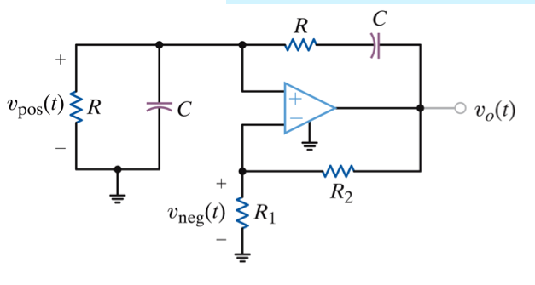

Figure 1. A Wein Bridge oscillator circuit is shown. The output of this circuit is a sinewave. The frequency can be controlled by the selecting appropriate values of R and C.

As you do your research, you will learn there are several variants of the circuit design shown in Figure 1. You are allowed to select any of these as long as you justify the selection in your lab report.

The tasks to be accomplished in this lab are:

1. Derive analytic expressions, known as the design equations, for the frequency of the resulting sinewave as a function of the component values.
2. Design the circuit to produce a sinewave at a frequency equal to:



For example, if your TUID is “123456789,” your center frequency would be:



1. Verify these design equations in Multisim by simulating the circuit and evaluating its performance. Include a measurement of the total harmonic distortion of the output sinewave. This can be obtained using the distortion analyzer module in Multisim. Google search “total harmonic distortion” or “THD” to learn more about this measurement.
2. Implement your circuit on your Digilent board using the best approximation to the component values you have in your parts kit. Modify the values of your Multisim simulation so that it matches your actual component values as closely as possible.
3. Verify that your hardware implementation matches your simulation by comparing both the center frequency of the sinewave produced and the harmonic distortion. Justify any discrepancies.
4. Digitize the sinewave generated into your laptop using the data collection set up that we developed in ECE 2312. Load the signal into MATLAB and compute its harmonic distortion using the tools provided in MATLAB (hint: look at the Signal Processing Toolbox or Google search this topic).

**Summary:**

Many electronic circuits with feedback paths are prone to oscillations, whether or not it is intended. The Laplace transform can be used to analyze the source of these oscillations and correct them.

Why does this circuit oscillate? This is a topic that will be covered in more detail in your Controls classes. However, at an intuitive level, when you have an inductor and capacitor in the same circuit, you have the potential for generating a system whose poles lie on the imaginary axis in the s-plane. As the inductor discharges, the capacitor charges, and vice-versa. This is one reason there is oscillation (but not the only reason :)

Additional things to think about include what is the role of the op-amp? How stable is this circuit when the op-amp and the circuit components undergo temperature variations? Would this circuit function properly if exposed to extremely cold temperatures, such as those found in outer space? How might you desensitize the performance of the circuit to variations in its component values or temperature?