Name:

Score: ____________________

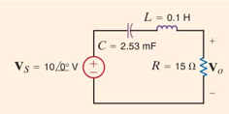

Compute and sketch Vo as a function of frequency using a Bode plot (20*log10 amplitude vs. 20log10 frequency). Be as detailed as possible on your sketch, labeling all critical points.