Name:

Score: ____________________

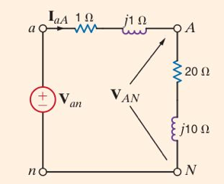

A three-phase wye-connected load is supplied by an abc-sequence balanced three-phase wye-connected source with a phase voltage of 120 V rms (Van, Vbn, Vcn). If the line impedance and load impedance per phase are 1+j1 Ω and 20+j10 Ω, respectively, we wish to determine the value of the load voltages (VAN).