Name:

Score: ____________________
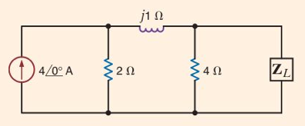
Find the value of Z_{L} that maximizes power transfer. Compute the value of the maximum power.

