Name:

Score: ____________________

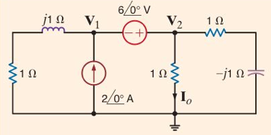

Find I0.