Name:

Score: ____________________

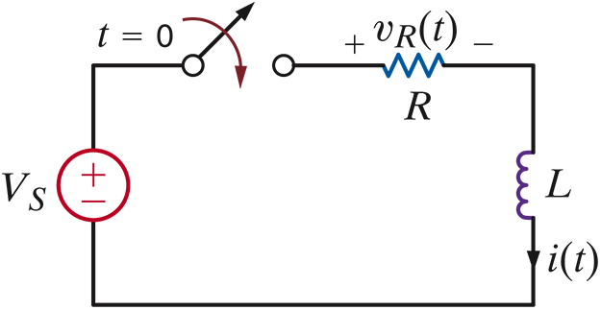

Derive an expression for i(t) using Laplace transforms.