Name:

Score: ____________________

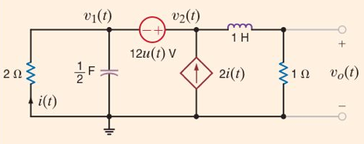

Find Vo(s) for the circuit shown.

(Hint: convert the circuit to the Laplace domain and use Thevenin’s Theorem.)