Name:

|  |  |  |
| --- | --- | --- |
| Problem | Points | Score |
| 1 | 20 |  |
| 2 | 20 |  |
| 3 | 20 |  |
| 4 | 20 |  |
| 5 | 20 |  |
| Total | 100 |  |

Notes:

1. The exam is closed books and notes except for four double-sided sheets of notes. You are allowed to use MATLAB for complex number calculations.
2. Please indicate clearly your answer to the problem. Circle your answers.
3. The details of your solutions are more important than the answers. Please explain your solutions clearly and include as many details as possible.

**1:**  Find Zth.

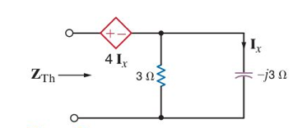

**2:**The current shown to the right flows through a 5Ω resistor. Calculate the average power dissipated. Compare this to the power that would be dissipated if the current were a sinewave of amplitude 4 amps.

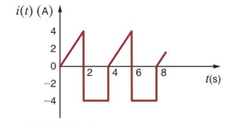

**3:** Determine the transfer function, H(s) = Vo(s)/Vs(s).

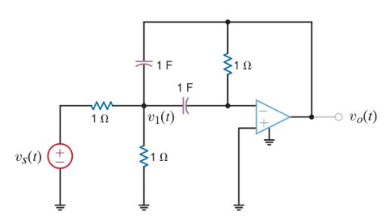

**4:** Find the Z parameters for the two-port network shown.

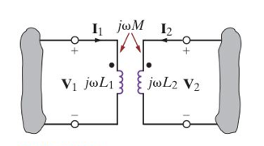

**5:** Determine the steady-state value of vo(t).

