Name:

|  |  |  |
| --- | --- | --- |
| Problem | Points | Score |
| 10.7 | 40 |  |
| 11.29 | 30 |  |
| 12.54 | 30 |  |
| Total | 100 |  |

Notes:

1. The exam is closed books and notes except for one double-sided sheet of notes. You are allowed to use MATLAB for complex number calculations.
2. Please indicate clearly your answer to the problem. Circle your answers.
3. The details of your solutions are more important than the answers. Please explain your solutions clearly and include as many details as possible.

**10.7:**  Find Vo in polar form (magnitude and phase).

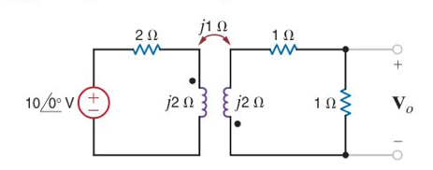

**11.29:**In a balanced three-phase wye–wye system, the total power loss in the lines is 400 W. VAN = 105.28/31.56° V rms (the magnitude is 105.28; the angle is 31.56°) and the power factor of the load is 0.77 lagging. If the line impedance is 2 + j1 Ω, determine the load impedance. (A balanced wye-wye connection is shown to the right. The line impedance appears in series between the three-phase sources, Van, Vbn and Vcn, and each of the loads.)

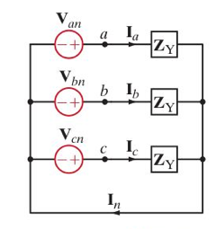

**12.54.**Determine the value of C in the network shown for the circuit to be in resonance.

