Name:

Problem | Points | Score
1 | 40
2 | 30
3(a) | 20
3(b) | 10
Total | 100

Notes:
- The exam is closed books and notes except for one double-sided sheet of notes. You are allowed to use MATLAB for complex number calculations.
- Please indicate clearly your answer to the problem. Circle your answers.
- The details of your solutions are more important than the answers. Please explain your solutions clearly and include as many details as possible.
1. Find i_{L}(t) for t > 0.
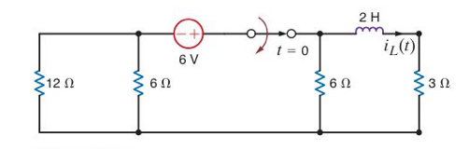

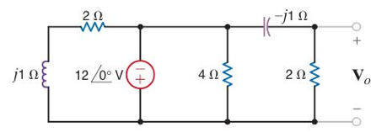
2. Find V_{o} (as a phasor).

3. (a) Calculate the RMS value of the waveform shown. Assume the signal is periodic with a period of 4 secs.
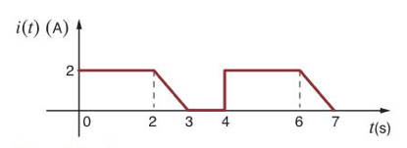

(b) Assume this signal is a current flowing through a 2 Ω resistor. How much power is dissipated? How does this compare to a sinewave with a 2 V peak amplitude? Explain.

