Name:

|  |  |  |
| --- | --- | --- |
| Problem | Points | Score |
| 1(a) | 20 |  |
| 1(b) | 20 |  |
| 2 | 30 |  |
| 3 | 30 |  |
| Total | 100 |  |

Notes:

1. The exam is closed books and notes except for one double-sided sheet of notes. You are allowed to use MATLAB for complex number calculations.
2. Please indicate clearly your answer to the problem. Circle your answers.
3. The details of your solutions are more important than the answers. Please explain your solutions clearly and include as many details as possible.

**1(a).**  Compute the Laplace transfer function for the network shown to the right.

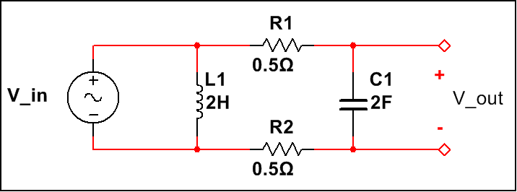

**1(b).**Sketch the Bode plot (log magnitude as a function of log frequency). You can use MATLAB for this. However, either way, explain why this plot makes sense. An explanation is required to get maximum credit.

**2.**Consider the circuit shown to the right. Compute the output voltage, vo(t) assuming vi(t) = u(t-1)-u(t-2). (Hint: sketch vi(t).)

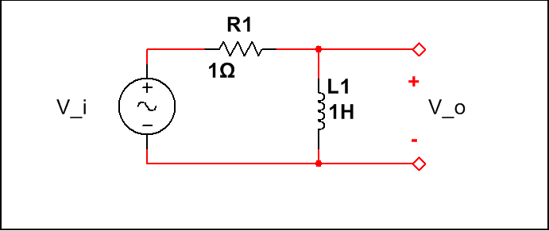

**3.** Compute the Laplace transfer function of the circuit shown to the right. If you can’t derive the expression, tell me as much as possible about the transfer function in a qualitative sense.

