ECE 2313: Electrical Engineering Science I

Laboratory No. 12: AC Power
The goal of this laboratory is to reinforce your understanding of the difference between active and reactive power. We will focus on using the Digilent board for these tasks, and compare the results to Multisim and your analytic solution.
Task 1: Series RC Circuit
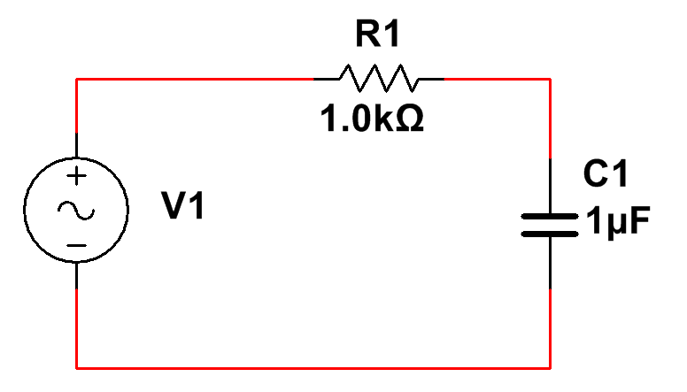
Figure 1. A series RC circuit is shown.

Implement the circuit shown in Figure 1 on the Digilent board. Use a 1V sinewave at a frequency of 200 Hz as input. Compute the power delivered by the source. Demonstrate that your calculation is correct by comparing that to Multisim and to an implementation on the Digilent board.
Also, measure the voltage and current across the resistor and capacitor, and create a spreadsheet showing that conservation of energy holds. Show the active and reactive power components for each of the components (including the source) and discuss whether these results make sense.
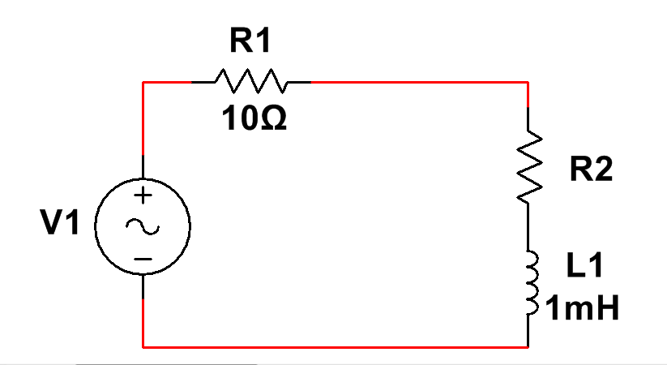
Figure 2. A series RC circuit is shown.

Task 2: Power Factor Correction
Assume the circuit shown in Figure 2 is a model of a power transmission system, with the resistor and inductor representing the load as a complex impedance. Use the same source voltage and frequency as in Task 1. Design the value of R2 such that the power factor for the load is 0.7. Verify your calculations through a Multisim and Digilent implementation. (Think carefully how you will demonstrate that the power factor is in fact the value that you claim.)
Add a capacitor in parallel to the load such that you improve the power factor to 0.9. Again verify this with a Multisim and Digilent implementation.
Task 3: Multiple Frequencies
Returning to the circuit of Figure 1, apply an input that is the sum of two sinewaves, one at 100 Hz, and a second at 200 Hz. Compute the average power dissipated in the resistor, R1, two ways. First, use superposition and measure each source independently. Next, apply the signal simultaneously. Explain how you arrived your values for the average power and whether this makes sense from a practical point of view. Verify your calculations with a Multisim and Digilent implementation.
Now set the frequency of the second sinewave to 123 Hz. Repeat your calculations and measurements. Again explain whether this makes sense. (Hint: think about how we derived the expression for average power).
Next, apply a square wave with a frequency of 100 Hz and a duty cycle of 50%. Compute the average power dissipated in the resistor. Explain your calculation and demonstrate that this matches what you observe in your hardware.
Finally, repeat this last step for a triangle wave, again with a duty cycle of 50%. What conclusions can you draw about the meaning of average power for these complex waveforms?
Don’t be afraid to look at the frequency content of these signals using the spectrum analysis tools in MATLAB or the spectrum analysis mode of your lab instrumentation.
Summary:
We have demonstrated several basic concepts about average power, including power factor and power factor correction. We also demonstrated the practical implications of active and reactive power.
In Task 3, you explored power calculations for more complex signals. This topic will be dealt with more extensively in your Signals and Systems course. Understanding the frequency content of a signal is a very important part of any power calculation. Power, RMS and other familiar terms are well understood for simple signals like a single sinewave (which is a good model of how the electric power grid works). However, for more complex signals, such as those you find in communications systems (e.g., a radio station’s transmitter), power calculations are much more subtle and require a good understanding of the frequency content of your signal and the frequency response of your transmission medium.

