ECE 2313: Electrical Engineering Science I

Laboratory No. 7: Printed Circuit Board Design
The goal of this laboratory is to introduce you to the basics of printed circuit board design using Multisim’s capability (Ultiboard). To begin, here are some online resources that will help familiarize you with the process of converting a schematic in Multisim to a PCB design: http://www.ni.com/white-paper/12242/en.
Also, in this lab we will design a filter based on the following specifications: http://www.wa4dsy.com/robot/bandpass-filter-calc. Please refer to this page when you need to calculate component values.
Task 1: Design
Use the URL above to calculate component values for the circuit shown in Figure 1. Set the center frequency of the filter to [1000 Hz - ‘your birthday’]. Use the day of the year for your birthday. For example, if you were born on January 10, use a value of “10” for your birthday. If you were born on February 1, use a value of 32. Set the 3 dB bandwidth to 200 Hz. Set the capacitor values to 0.1 μF. Set the gain to 1.0.
Unfortunately, you do not have precision resistors to implement the above design. Therefore, working from your parts kit and the ECE Shop’s inventory of standard resistors and capacitors, modify the above component values to match values you have available to you. You can adjust values in Multisim to match the precise values that you decide to use.
Task 2: Rapid Prototyping
Using the component values you have determined from Task 1, implement the circuit shown in Figure 1 in Multisim and on the Digilent board. Apply a 1V sinewave as an input to the circuit. Measure the output voltage as a function of frequency over the range [0, 10 kHz] by varying the frequency of your sinewave. Plot the voltage as a function of frequency in Multisim (using the sweep function), and demonstrate that your Digilent implementation produces the same results (by comparing plots).
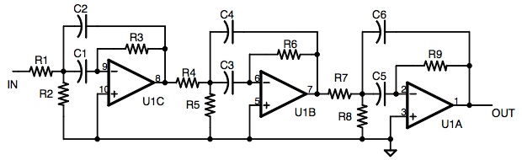
Figure 1. A three-stage op-amp circuit that implements a 6-pole active bandpass filter. We will use this basic design to explore how to generate a printed circuit board from a Multisim schematic.

Task 3: PCB Design Using Ultiboard
Review the documentation provided by National Instruments at http://www.ni.com/white-paper/12242/en. Starting with your Multisim simulation of the final filter design, generate a printed circuit board (PCB) layout using Ultiboard. Your TA will assist you with this step since there are some details involved in generating this design. Your goal is to design a very basic two-sided board, which has components on one side, and solder pads on the other. We will use an IC socket for the op-amp chip so that it can be easily removed. Be sure to insert your name on your board.
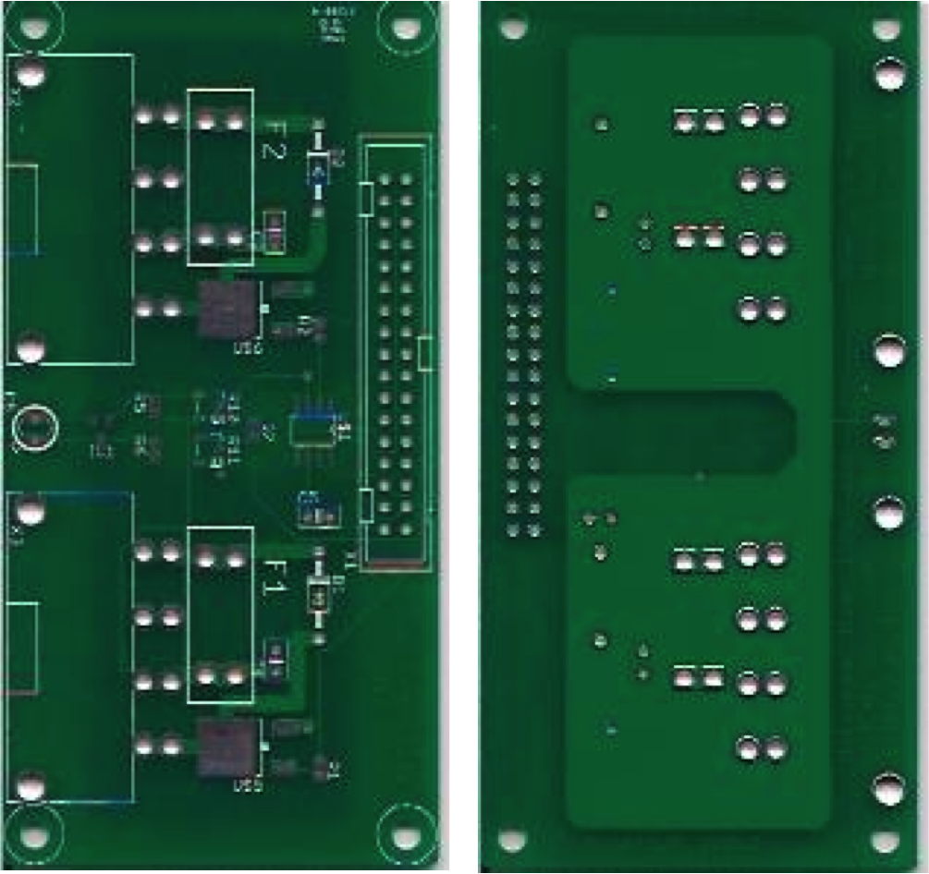
Figure 2. An example of a simple two-sided PCB generated from Multisim using Ultiboard.

Your PCB, when fabricated, will look something like what is shown in Figure 2. (Note that the circuit shown is not the actual circuit you are building, but simply an example fabricated in Senior Design. We can show you a sample of the board if you are interested.) The design you are sending out is just the circuit board layout. You will be responsible for populating the board with components, soldering them, and testing. This will be covered in a future lab near the end of the semester.
You must submit your output file, known as a Gerber file (see http://en.wikipedia.org/wiki/Gerber_format for more details about this file format), to your TA by 5 PM on October 26. We will send these out to a board fabrication service (see http://www.4pcb.com/pcb-student-discount.html) to be fabricated. They will be returned in roughly three weeks. If you miss this deadline, you will not have your board fabricated.
If you need more time to do the testing and write your lab report, please coordinate that with your TA. However, still proceed to lay the circuit out in Multsim and generate the PCB. The PCB design won’t change as you change component values to optimize your circuit.
Summary:
The main goal of this laboratory is to introduce you to the basic process of PCB design. This is a useful skill that will be required when you reach Senior Design. Rapid prototyping of electronic circuits has advanced significantly in the past 50 years. Today, from your desktop, you can design, fabricate and even mass produce a circuit board. The board can be fabricated from any number of vendors around the world and delivered to your desktop in a relatively short amount of time. All of this can be done from within Multisim. PCB design is truly a global enterprise.

