ECE 2313: Electrical Engineering Science I

Laboratory No. 6: Op-AmP Amplifiers
The goal of this laboratory is to reinforce your ability to analyze op-amp circuits by designing and implementing several common configurations. We will also explore key issues such as power consumption.
Task 1: Noninverting Amplifier
Derive the gain equation for the noninverting amplifier configuration shown in Figure 1. Verify this equation in Multisim using R₁ = R₂ and R₁ = 10*R₂.
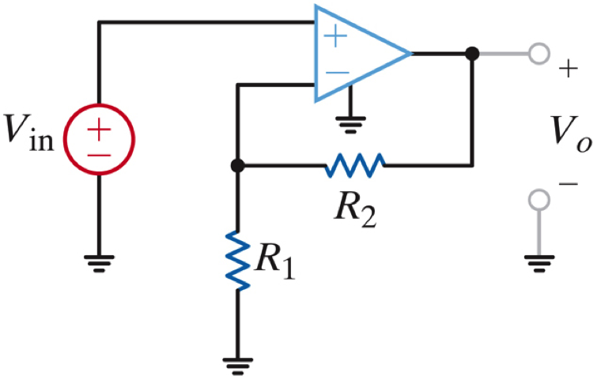
Figure 1. A noninverting amplifier whose gain is controlled by R₁ and R₂ is shown.

Implement the circuit on your Digilent board for the case of R₁ = R₂ = 1kΩ. Set V_{in} = 1V. Set V_{cc} = 5V and V_{ee} = -5V. Verify that all voltages and currents match what your simulation predicts. Explain any discrepancies.
Next, using the parameter sweep function in Multisim, vary V_{in} over the range [-6V, 6V]. Plot the output voltage. Explain what you observe.
Finally, set V_{in} = 1V and verify that conservation of energy holds. Do this by measuring the power supplied by V_{in}, V_{cc}, V_{ee}, as well as the power dissipated in the resistors. Present this in a spreadsheet that accounts for each component in the circuit.
What power dissipation have you not accounted for? Why do you get a voltage gain? Do you observe a power gain? If not, explain.
Task 2: Differential Amplifiers
Repeat Task 1 for the circuit shown in Figure 2. Derive the equations for the output voltage as a function of the two input voltages. Then set R₁ = R₃ = 1kΩ and R₂ = R₄ = 1kΩ. Verify that your implementation on the Digilent board matches your Multisim implementation.
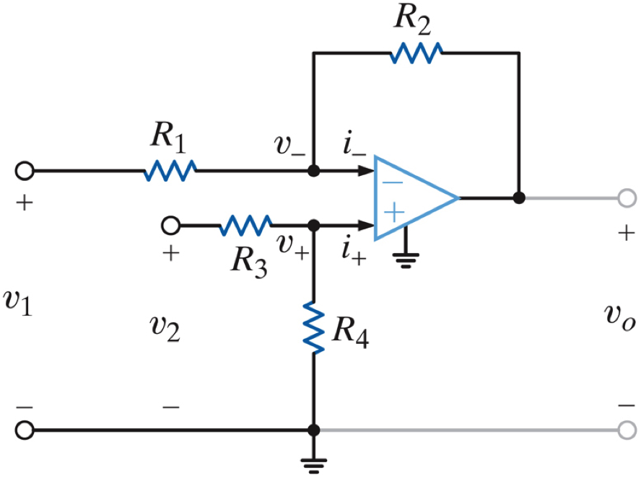
Figure 2. A differential amplifier is shown in which the gain for each channel can be controlled independently.

Next, adjust R₂ so that the output voltage, which should be the difference of the input voltages, is amplified by a factor of 2. Demonstrate that your hardware results match Multisim.
Verify once again that conservation of energy holds by measuring the power supplied and dissipated, and presenting this in a spreadsheet that accounts for all power consumed or supplied.
Task 3: Cascaded Noninverting Amplifiers
Starting with your design in Task 1, design a two-stage amplifier for which the gain of the first stage is 1.0, and the gain of the second stage is 10.0. This simply means the output of the first stage serves as the input to th second stage. Verify that your implementation matches what Multisim predicts. For this task, set V_{cc} = 5V and V_{ee} = -5V. Vary V_{in} over the range [-6V, 6V] and record what you observe. Investigate the source of any unexpected behavior, such as saturation, by probing the circuit and showing exactly where saturation is occurring (if, in fact, it is occurring).
Explain why when you cascade these amplifiers, the properties of the first amplifier was not altered because of impedance loading. Verify this by probing the hardware and measuring key parameters, such as impedance and currents. Construct a logical argument why the first amplifier serves as a buffer amplifier (if in fact it does :)
Summary:
Op amps are extremely useful circuit components because they allow us to use a building block approach to circuit design. You can “decouple” or isolate one circuit from another. They are also very easy circuits to design and tune to achieve a desired performance level.
Next week we will begin a printed circuit board design that involves the implementation of a multistage op-amp design that functions as a filter.

