ECE 2313: Electrical Engineering Science I

Laboratory No. 5: The Wheatstone Bridge
The goal of this laboratory is to reinforce your ability to analyze DC circuits by demonstrating one of the classic circuits used to measure unknown quantities. For this lab, you will construct three versions of the same circuit (Multisim, Digilent, punch board) and verify that they all operate correctly.
Task 1: Circuit Analysis
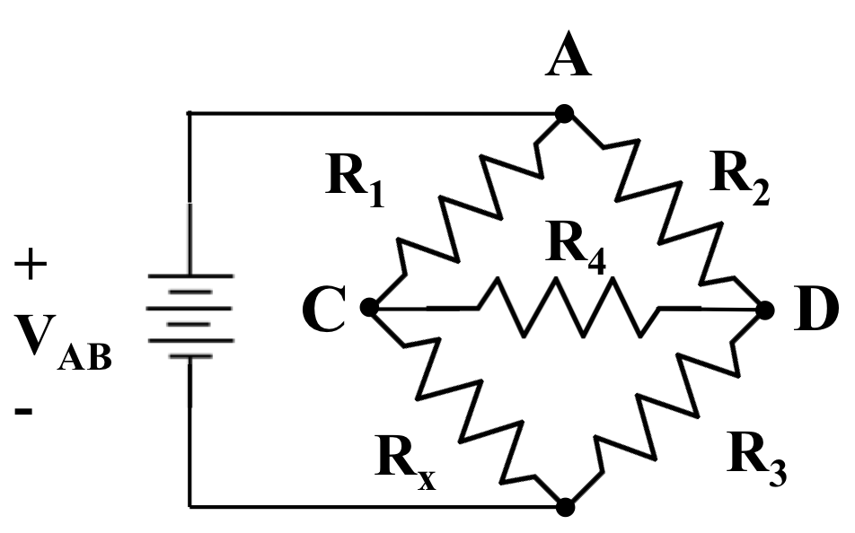
Figure 1. An electrical circuit known as a Wheatstone Bridge is shown. Before test instrumentation became readily available, this circuit was used to measure the resistance value of an unknown device.

We can use the circuit shown in Figure 1 to measure the value of an unknown resistor, R_{x}. However, to do that, we need to know the precise values of R₁, R₂ and R₃. Further, we need to adjust R₂, a known quantity so that the current flowing through R₄ is zero (why?).
Derive a set of equations that determines the resistance of R_{x} in terms of the other quantities in the circuit. Derive these equations by writing equations for all the voltages and currents in the circuit, and then simplifying them. Use Multisim to verify the accuracy of this equation.
Next, demonstrate the impact tolerances have on the accuracy of your measurement. For example, suppose you specify a value of 1 kΩ for R₁ and R₃, and the actual value of R₁ is 10% smaller, while the actual value of R₃ is 10% larger. How does this influence your measurement?
Task 2: Rapid Prototyping
Design the circuit in Figure 1 to measure resistances in the range of 500 Ω to 1,500 Ω using your analysis from Task 1. You might consider using a potentiometer, which is simply a variable resistor in this design. Implement your design on your Digilent board. Compare its performance to your simulation by comparing the predicted and actual voltages and currents.
Once you have verified its operation is correct, your TA will provide you with an unknown resistor. Measure its resistance using your circuit and compare that with what you measure using your ohmmeter.
Task 3: Implementation
Solder an implementation of your circuit board using the punch board provided in your electronics kit. Repeat Task No. 2. Demonstrate that your three implementations (Multisim, Digilent and punch board) produce the same results. Explain any discrepancies, including differences due to tolerances of the components. How many significant digits can you obtain from this crude measurement device? Explain.
Summary:
It is difficult to measure the value of a component without some reference point. In this laboratory, you have learned how to design a circuit that you can use to measure unknown quantities relative to some known quantities. The principles behind a Wheatstone bridge are universal and apply to many other engineering fields.

