ECE 2313: Electrical Engineering Science I

Laboratory No. 4: MATLAB CO-DESIGN
The goal of this laboratory is to demonstrate that MATLAB can be used as a signal generator and as a signal analyzer. For this lab, we will need two new capabilities. First, you must have MATLAB installed on your laptop. You should have done this in ENGR 1101 (Introduction to Engineering) as well as Lab No. 1. Instructions for how to download and install MATLAB can be found by logging into https://download.temple.edu/ and selecting the MATLAB link.
We are going to introduce you to some new capabilities in MATLAB – namely the ability to play and record audio signals. One of the nice features of MATLAB is that the user base is extremely large, and hence the number of web pages explaining its features is enormous. There is a web page for just about anything you want to do in MATLAB – just ask a question using your favorite search engine. In this lab, you will need to consult the web to learn how to do some of the things described below because we haven’t covered them in class yet. For better or for worse, this is how it works in real engineering work environments, so let’s work on building up your network of resources.
Since this lab touches on a bunch of topics we haven’t covered in class, please remember that your teaching assistant (TA) is here to help. That does not mean he/she is supposed to give you answers to questions. However, your TA is here to make sure you don’t thrash endlessly on little problems, and that you can make progress on these problems. Don’t be afraid to consult your TA if your don’t understand something.
Second, we need a way of interfacing your audio system to a breadboard. Let’s build a cable. But first...
PLEASE HAVE YOUR TEACHING ASSISTANT CHECK THE INTEGRITY OF YOUR CABLE AND OTHER CONNECTIONS BEFORE YOU ATTEMPT TO CONNECT ANYTHING TO YOUR LAPTOP!
We want you to avoid damaging your laptop, so we need to be very careful checking connections before anything is connected to your laptop.
Task 1: Fabricate An Interface Cable
Now that you are an expert in soldering, we will put those new skills to work. We will need to create a cable that allows you to easily interface the audio input and output on your laptop to a breadboard. The cable you will need to fabricate should look something like what is shown in the middle of Figure 1 (except that you want three connectors because the mini plug is a stereo plug).
The audio output on your laptop, which is typically used to plug into headphones or an amplified speaker, uses a 1/8” stereo mini plug. How many wires are in this cable? How does the ground work? Use an ohmmeter and find out!
There are a number of ways you can fabricate this cable:
- Cannibalize a cheap headphone cable by stripping the wires and soldering alligator clips to the exposed wires.
- Purchase a standard converter cable shown in Figure 1, and use test leads available in the lab to connect the RCA cables to your breadboard.
- Directly fabricate a cable starting with a 1/8” phono mini plug, two alligator clips and some wire.
We will leave the details to you. The end result should be a cable with a mini plug on one end and three alligator clips on the other. Include in your final lab report a picture of the cable you made and a schematic of its pinout (even if you purchased a prefabricated cable). You can use your ohmmeter to verify that your cable is constructed properly.
Task 2: Audio Files in MATLAB
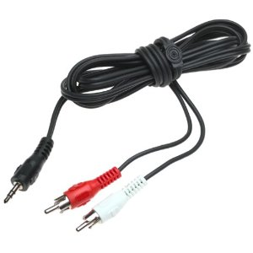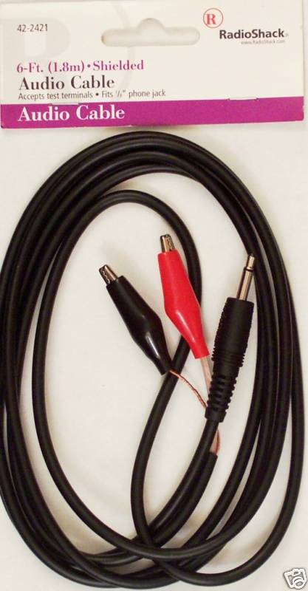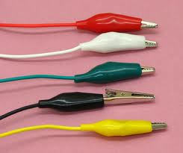
Figure 1. A cable that converts an 1/8" stereo mini plug to two male RCA connectors is shown on the left. This is a standard cable found in most electronics stores or departments. The picture in the center shows a cable that converts a mono stereo mini plug into two alligator clip leads. We recommend using alligator clips, shown on the right, for your connectors.

Connect the audio speaker available in the Digilent parts kit to your laptop via the cable created in Task 1. You can use the Digilent breadboard for this if you prefer. Acquire an audio file of your favorite music from the Internet (legally). Load this file into MATLAB and use a suitable play function to play this file through the internal speaker on your laptop (just a sanity check). Next, with your speaker connected to your laptop, direct the audio output to the speaker output and play the file through your Digilent speaker. Connect your Digilent oscilloscope to the speaker inputs. Record a 100 ms segment of the file using your Digilent oscilloscope. Display this waveform in your lab report as a proof of concept that you can play a file through your laptop using MATLAB. Note any issues (hint: is it a stereo file?).
The audio file you are playing is actually a digital signal. The file on your computer is nothing more than a list of numbers. There is a sampling frequency associated with this signal, typically 44.1 kHz, that describes how far apart in time the samples are spaced. Your laptop’s audio hardware converts this file to an electrical signal that can be injected into devices like headphones, speakers, etc. You can think of the combination of these capabilities as a fancy software-controlled signal generator.
One reason it is important to work from data stored in computer files is that it is much easier to replicate experiments. You have the data stored permanently in a file, which makes it very easy to go back and reproduce your results. When you save your measurements to files as well, you have permanent documentation of what signals were used as inputs and outputs. This type of detailed recordkeeping is a very important part of your experimental process.
Interfacing to the microphone input on a laptop is a similar process. Microphone inputs on most, if not all laptops are mono inputs (meaning one channel). If your laptop has a microphone input, you can use the same cable you fabricated to record audio. The only difference is that the signal level for the microphone input is small – a peak value of 100 mV is typical. We have to be very careful when connecting this input to a circuit to measure voltage.
Demonstrate that you can record an audio signal in MATLAB by using the built-in recording function. Record an audio signal from the internal microphone while you speak the numbers “123456789” and plot 100 ms of the resulting signal in MATLAB. Capture a screen shot for your lab report. Pick a section of the waveform where the amplitude of the signal is high (e.g., not the first 100 ms).
It is also possible to purchase a USB peripheral that contains analog to digital converters. This is more common when you are instrumenting a high quality laboratory set up. These devices can provide high quality recordings at much higher sample rates. Such fidelity won’t be needed during this course.
The outcome for this task is to teach you that the combination of MATLAB and your laptop gives you a very powerful capability to generate test signals, record signals and do signal analysis. If you couple this with software like LabView, you can create automated experimental set ups that are completely controlled from your laptop. This is a very common way to run experiments today. Even hardware engineers use software!
Task 3: Signal Generation in MATLAB
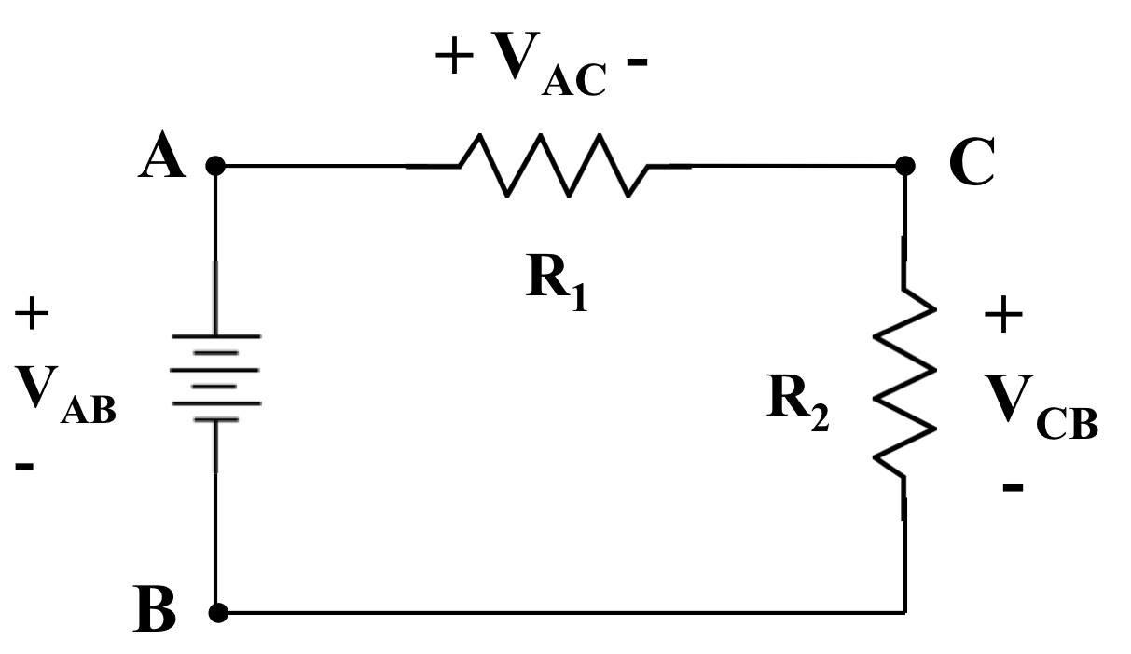
Figure 2. A simple circuit is shown that consists of a 1V DC source and two resistors connected in series. This is sometimes referred to as a voltage divider.

Recall our simply voltage divider shown in Figure 2. Ignore the voltage source – we will use your laptop as the voltage source. This is a reasonable model for the audio output of your laptop when it is connected to a speaker. In this task, we are going to measure the frequency response of a resistor and a capacitor. Set R₁ and R₂ to 1 kΩ. Connect your Digilent oscilloscope to measure the voltage across R₂, V_{CB}, and the input voltage to your circuit, V_{AB}.
Generate a series of sinewaves in MATLAB with an amplitude of 1.0 and frequencies of 100 Hz, 200 Hz, 300˙Hz, ..., 1,000 Hz, 2,000 Hz, 3,000 Hz, ..., 10,000 Hz. Generate signals that are 10 seconds long. Use a standard audio sampling frequency of 44.1 kHz. Save each of them to a separate audio file.
Connect the audio output of your laptop to serve as the voltage source in Figure 2. Apply each of the above sinewaves to your circuit. Measure the peak amplitude of V_{AB} and V_{CB} (the value from a 0 reference voltage to the highest positive-going part of the waveform). In MATLAB, plot the ratio of V_{CB}/V_{AB} as a function of frequency using a log base 10 scale for frequency. Comment on your findings. (You can find instructions on how to plot data in MATLAB using the built-in MATLAB help functions or on the web as well.)
Next, repeat this using a 1 μF capacitor in place of R₂. Comment on the differences between these two plots.
Finally, repeat this by replacing R₁ with a 1 mH inductor and R₂ with your Digilent speaker. Again measure the frequency response and plot it in MATLAB. Compare and contrast these three plots. Why is the behavior as a function of frequency different?
Task 4: Complex Signal Generation in MATLAB
Now that you know how to interface MATLAB to your circuit, you can use the power of MATLAB to generate many complex signals. You can also record the resulting data into MATLAB and do analysis of the data using MATLAB’s powerful analytic tools. In future semesters, you will learn how to use some of MATLAB’s advance simulation capabilities, namely SIMULINK, to control hardware in real time.
Repeat the first part of Task 3 using a square wave with a 50% duty cycle. A square wave is a signal whose amplitude is 1.0 for a portion of time, and then 0.0 for the remainder of its cycle. It is a periodic signal just like a sinewave. The duty cycle refers to the ratio of the time the waveform has a value of 1.0 divided by the time the waveform is 0.0. A 50% duty cycle simply means the signal is “on” half of the time, an off the other half of the time. A 30% duty cycle means that for a signal with a frequency of 1 Hz, or a period of 1 sec, the signal is “on” for 0.3 seconds.
Plot the peak value of the voltage that you see as a function of frequency.
Next, select a frequency of 1 kHz, and vary the duty cycle from 20% to 80% in steps of 10%. Plot the voltage ratio as a function of duty cycle. Do these results surprise you?
Finally, repeat this process for the second part of Task 3 where you use a capacitor instead of a resistor. Plot the voltage ratio as a function of frequency. Do these results differ from what you saw for the sinewaves? If so, can you explain why?
Summary:
In this laboratory, we have introduced you to a powerful new piece of instrumentation, MATLAB. With this software, your laptop now becomes the center of your hardware laboratory. You use your laptop to generate, measure and analyze signals. You can also use your laptop to control experiments.
We have also continued to introduce you to the concept of frequency response. Once we reach AC circuit analysis, the results you are seeing in the lab will make more sense. For now, we simply want you to observe behavior to stimulate your thinking about what is different between DC and AC systems. Once you reach ECE 3512 (Signals: Continuous and Discrete), you will learn how all these things are related and can be easily explained using Fourier and Laplace Transforms.

