Name:

Score: ____________________
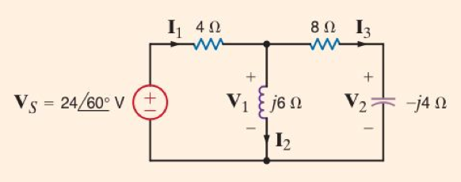

Find I₁.

