Name:

Score: ____________________
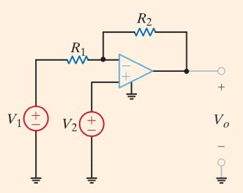

Find an expression for V_{o} in terms of V₁ and V₂.

