Name: Score: ____________________

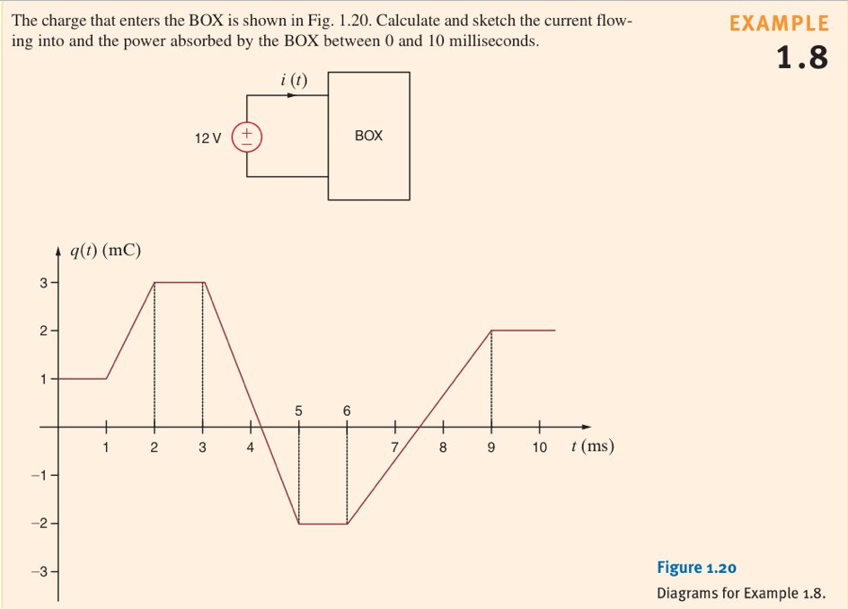

Recall:  and .