Name:

Problem | Points | Score
1 | 40
2 | 20
3 | 40
Total | 100

Notes:
- The exam is closed books and notes except for one double-sided sheet of notes. You are allowed the use of a calculator or MATLAB on this exam, but only to do complex number calculations.
- Please indicate clearly your answer to the problem. Circle your answers.
- The details of your solutions are more important than the answers. Please explain your solutions clearly and include as many details as possible.
1. Determine the current through the inductor, i_{L}(t), as a function of time (derive an equation). Sketch your result for t = [-1.0, 10] and label as much of the plot as possible (e.g,, time constant, initial value, final value). (Hint: Write the form of the response and solve for the constants.)
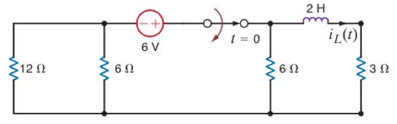

2. Find the equivalent input impedance assuming a frequency of 60 Hz.
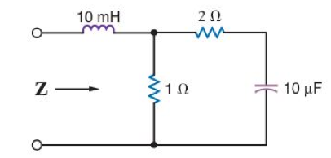

3. Find V_{x} (Hint: Use Norton’s Theorem to convert the current source to a voltage source).
