Name:

Problem | Points | Score
1 | 30
2(a) | 30
2(b) | 10
3 | 30
Total | 100

Notes:
- The exam is closed books and notes except for one double-sided sheet of notes.
- Please indicate clearly your answer to the problem. Circle your answers.
- The details of your solutions are more important than the answers. Please explain your solutions clearly and include as many details as possible.
1. Derive an expression for V_{o} as a function of V₁ and V₂.
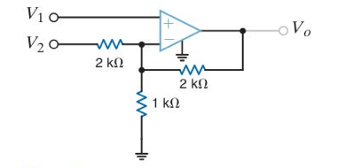

2. (a) Using superposition, find the value of R_{L} that maximizes the power dissipated in R_{L}. Compute the portion of this power due to the voltage source only, and the portion due to the current source.
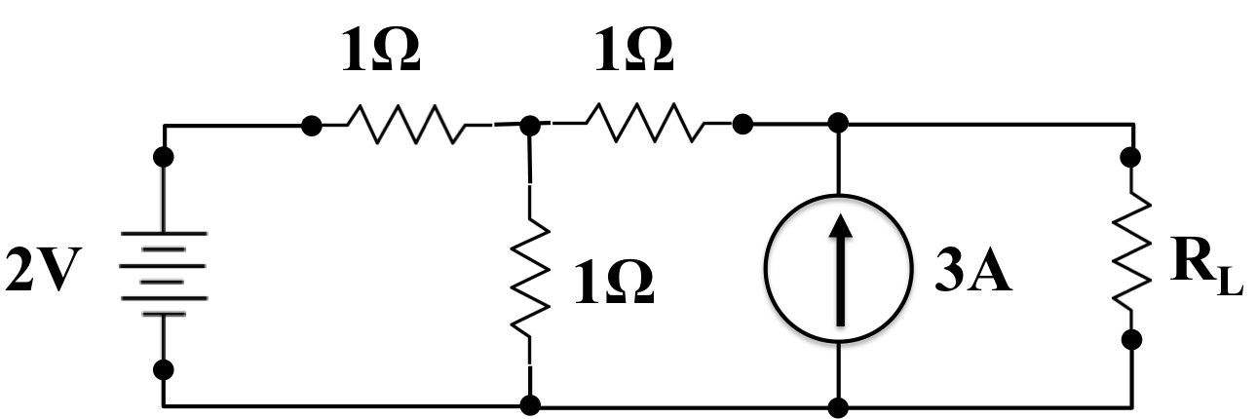

2(b). Remove the current source by treating it as an open circuit. Find the value of RL that maximizes the power dissipated in RL. Explain why this value is the same, or different, than the answer to (a). Justify your conclusion whether it should be the same or different.

3. Find the energy stored in the 2F capacitor and 3H inductor. (Hint: find all voltages and currents first.)
