Name:

Problem | Points | Score
1(a) | 10
1(b) | 15
2(a) | 10
2(b) | 10
2(c) | 15
2(d) | 10
3(a) | 15
3(b) | 15
Total | 100

Notes:
- The exam is closed books and notes except for one double-sided sheet of notes.
- Please indicate clearly your answer to the problem. Circle your answers.
- The details of your solutions are more important than the answers. Please explain your solutions clearly and include as many details as possible.
1(a). Compute the equivalent resistance for the network shown to the right.
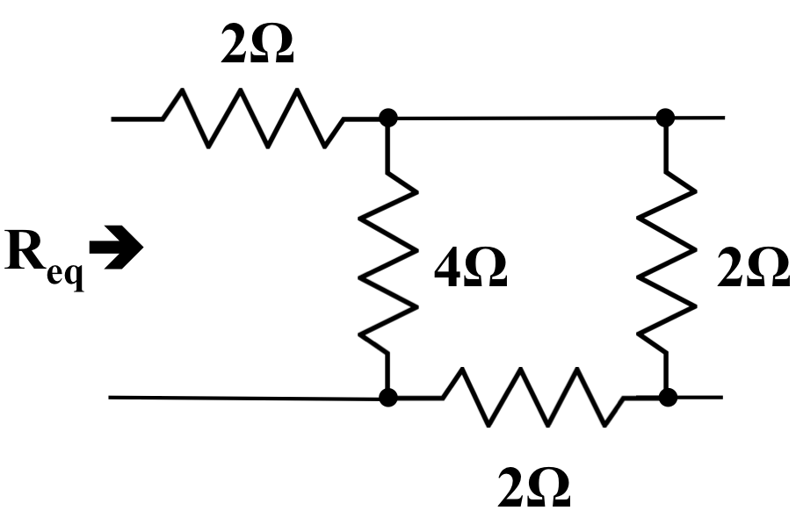

1(b). A 2Ω resistor is placed as a load on this network. Computer the equivalent resistance and explain any changes in the overall resistance that you observe.
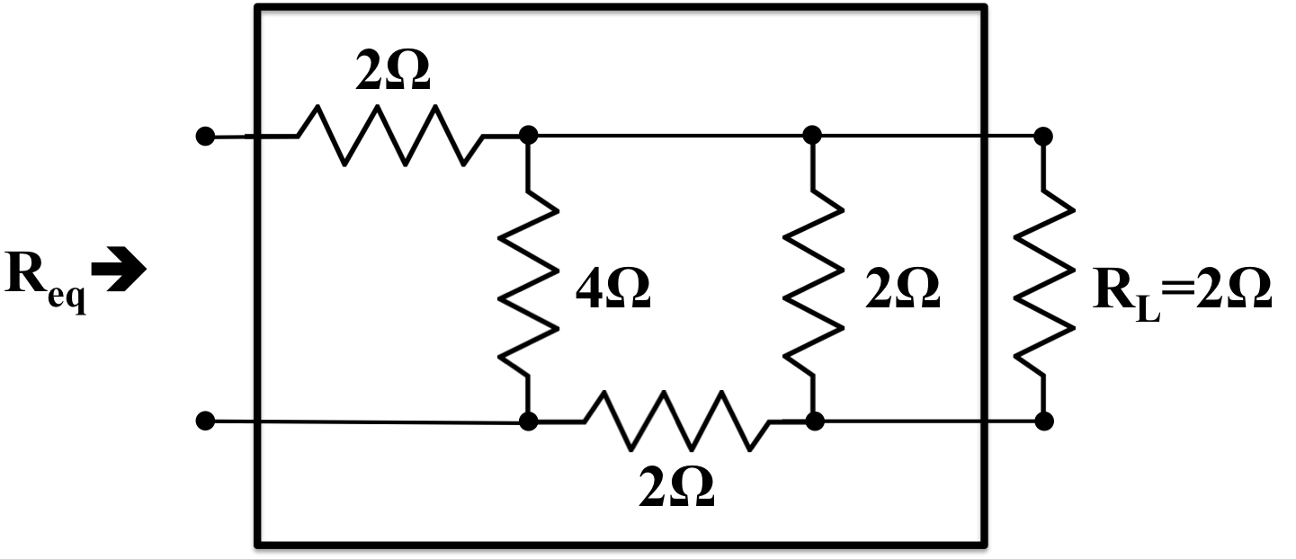

2. Consider the circuit shown to the right.
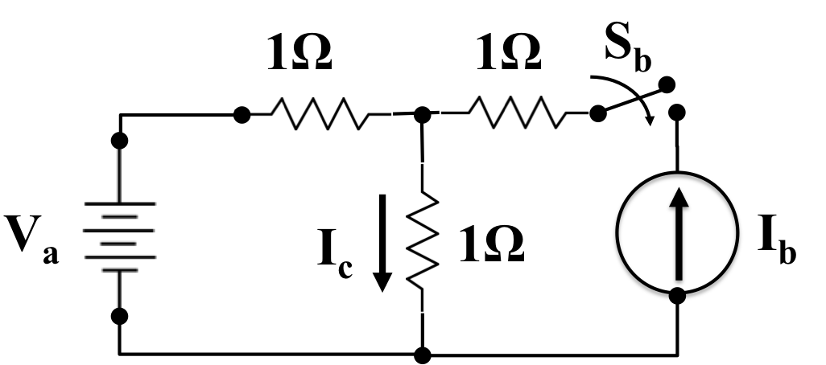

2(a). Set V_{a} = 1 VDC and compute the current in the center resistor, I_{c}.

2(b). Set V_{a} = 0 VDC, close the switch S_{b}, and set I_{b} = 1A. Compute the current in the resistor, I_{c}.

2(c). Set V_{a} = 1 VDC, close the switch S_{b}, and set I_{b} = 1 A. Compute the current in the resistor, I_{c}.

2(d). Does the result of (c) equal the sum of 2(a) and 2(b)? Explain any differences that you observe.

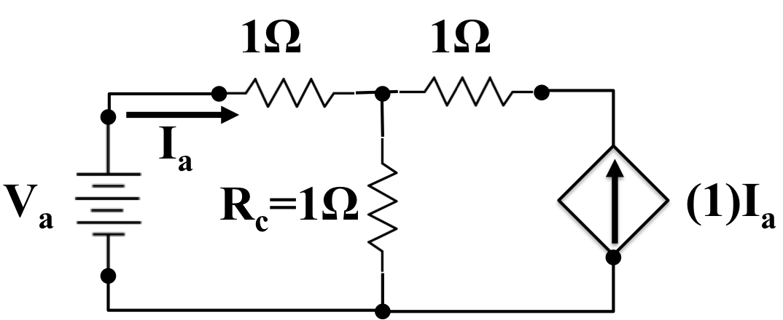
3. For the circuit shown to the right, assume V_{a} = 1 VDC:

3(a). Compute the power dissipated in R_{c}.

3(b). Compute the power delivered by the source, V_{a}.

