Name:

|  |  |  |
| --- | --- | --- |
| Problem | Points | Score |
| 1(a) | 15 |  |
| 1(b) | 15 |  |
| 1(c) | 15 |  |
| 2(a) | 15 |  |
| 2(b) | 15 |  |
| 3(a) | 15 |  |
| 3(b) | 10 |  |
| Total | 100 |  |

Notes:

1. The exam is closed books and notes except for one double-sided sheet of notes.
2. Please indicate clearly your answer to the problem.
3. The details of your solutions are more important than the answers. Please explain your solutions clearly and include as many details as possible.

**1.** For the adaptive system shown to the right, assuming *f*(*n*) is a linear, time-invariant moving average filter:

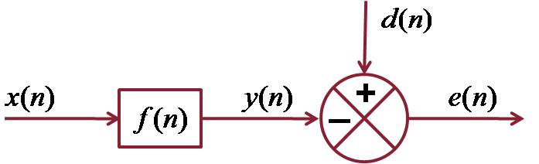



(a) Derive the normal equations for the minimum least squares error estimate of the filter coefficients.

(b) Develop the concept of a linear prediction filter based on this model (explain how this model is modified to produce a linear prediction estimate of the filter coefficients).

(c) Derive the expression for the autocorrelation estimate of the linear prediction coefficients.

**2.** Modify the block diagram shown above to produce the basic LMS adaptive filter.

(a) Derive an expression for estimation of the filter coefficients using an iterative-in-time approach.

(b) Compare and contrast this to the approach in Prob. 1.

**3.** Suppose the input signal to the adaptive filter shown above is as follows: Assume is zero-mean white Gaussian noise.

(a) Explain how successful the filter in no. 2 will be at correctly estimating the underlying parameters of this signal. Be as specific as possible and use terms such as the bias, variance, and convergence.

(b) Explain under what conditions we prefer approach no. 2 over approach no. 1. Again, be as specific as possible in your explanation, discussing issues such as, but not limited to, computational complexity.